AML Transaction & Fraud Analysis

Using Microsoft Power BI

Project Report
Submitted by: Hemani rajesh
Roll No.: E25FA011
Department: B.COM (Fintech with AI)
Year: 2nd year
Tool used: Microsoft Power BI Desktop

Introduction
This project documentation provides a comprehensive operational overview of Anti-Money Laundering (AML) monitoring and fraud detection using the AML Transaction & Fraud Analysis Dashboard. Developed within Microsoft Power BI Desktop, this interactive analytics system empowers financial compliance teams and risk officers to monitor transaction volumes, isolate illicit monetary flows, evaluate financial exposure, and analyze fraud typologies across high-risk accounts.

Objectives
  - Track high-level Anti-Money Laundering metrics including overall transaction count, total monetary volume, total monitored accounts, and confirmed fraudulent transactions.
  - Monitor transactional velocity over time using timestamp-based line trends to detect anomaly spikes.
  - Classify financial alerts by laundering typologies, specifically focusing on cycle and
fan_in paflerns.
  - Evaluate the proportional split between legitimate transactions (False) and flagged fraudulent activity (True).
  - Analyze total financial exposure (monetary value) tied to fraudulent vs. legitimate transaction behavior.

Dataset Description
The underlying dataset captures financial network transactions, risk flags, and suspicious activity monitoring logs. Key data fields modeled within the Power BI dashboard include:
  - Accounts - It contains information details regarding Customer and their accounts details like Account ID, Account type, Country, Customer ID, Customer Name, Balance, IS_Fraud
  - Alerts - Alerts contains data about suspicious transaction - Alert ID, Alert type, IS fraud, Receiver account, sender account, timestamp, etc.
  - Transactions - It cointains transaction details Is Fraud, Total Transaction, Total transaction Amount , TX ID, Average Transaction, Etc.

Data Preparation
  - Data Cleaning & Type Casting: Formafled monetary fields (TRANSACTION AMOUNT) into standard currency data types and converted binary flags into boolean/text aflributes.
  - Alert & Typology Mapping: Categorized alert triggers into explicit laundering structures (cycle for circular fund transfers and fan_in for aggregated multi-account structuring).
  - Data Aggregation: Calculated aggregate metrics including total transaction volume, total fraud count, and cumulative financial exposure.
  - Remove Errors and changed the datatype of each column in the dataset.

DAX Measures Used
Key DAX formulas built within Power BI Desktop to calculate core compliance metrics:
  - TOTAL TRANSACTION AMOUNT - Total Transaction Amount = SUM(Transactions[TX_AMOUNT])
  - TOTAL TRANSACTION - Total Transactions = COUNT(Transactions[TX_ID])
  - TOTAL ACCOUNTS - Total Accounts = DISTINCTCOUNT(Accounts[ACCOUNT_ID])
  - AVERAGE TRANSACTION AMOUNT = Average Transaction Amount =

AVERAGE(Transactions[TX_AMOUNT])
  - TOTAL INITIAL BALANCE = Total Initial Balance = SUM(Accounts[INIT_BALANCE])
  - FRADULENT TRANSACTION = Fraudulent Transactions =
CALCULATE(
COUNT(Transactions[TX_ID]),
Transactions[IS_FRAUD] = TRUE()
)

Dashboard Components

Executive Summary KPI Cards:
    - TOTAL TRANSACTION: 1M
    - TOTAL TRANSACTION AMOUNT: $153.48bn ($153.479506205bn)

TOTAL ACCOUNTS: 10K
    - FRAUDULENT TRANSACTION: 2K

  - TRANSACTION VOLUME ACROSS THE TIMESTAMP: Line chart displaying steady baseline transaction volume ranging between 6,000 and 7,200 transactions per timestamp block.
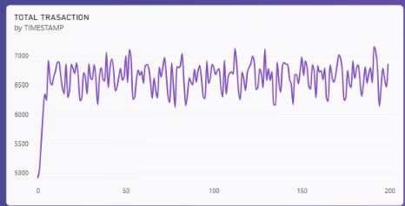
  - FRADULENT TRANSACTION VOLUMN ACROSS TIMESTAMP : Time-series line chart tracking specific high-risk transaction fluctuations between 0 and 17 events.
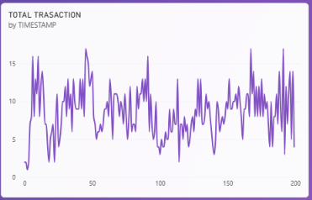
  - TRANSACTION DISTRIBUTION BY FRAUD STATUS: Donut chart highlighting the breakdown of transactions: 99.87% (1M) Legitimate (False) vs 0.13% (0M / 2K count) Fraudulent (True).
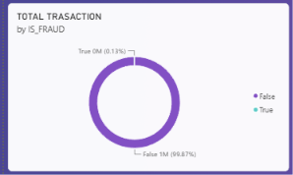
  - ALERT by ALERT TYPE: Horizontal bar chart comparing detected laundering typologies, showing cycle alerts (~920 alerts) leading over fan_in alerts (~780 alerts).
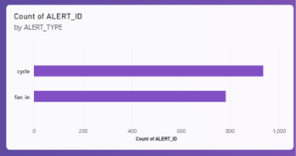
  - TOTAL TRANSACTION VALUE BY FRAUD: Column chart illustrating financial exposure: legitimate transactions account for the vast majority of the $153.48bn volume, while fraudulent transactions represent a focused high-risk subset.

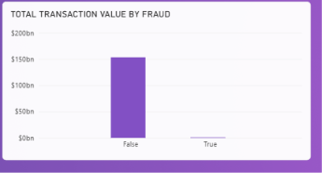

Slicers Used
  - ALERT_TYPE Slicer: Radio buflon selection panel allowing compliance teams to isolate transactions by specific laundering paflerns (cycle or fan_in).
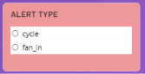
  - IS_FRAUD Slicer: Radio buflon selection panel enabling quick toggling between non-fraudulent (False) and flagged fraudulent (True) transactions.
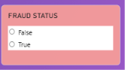

Tool tips

In this report, tooltip is used to analyze the Transaction Volume across the timestamp through KPI cards at Tooltip page.

KPI cards include:

Total transaction

Total transaction amount

Fraudulent Transaction

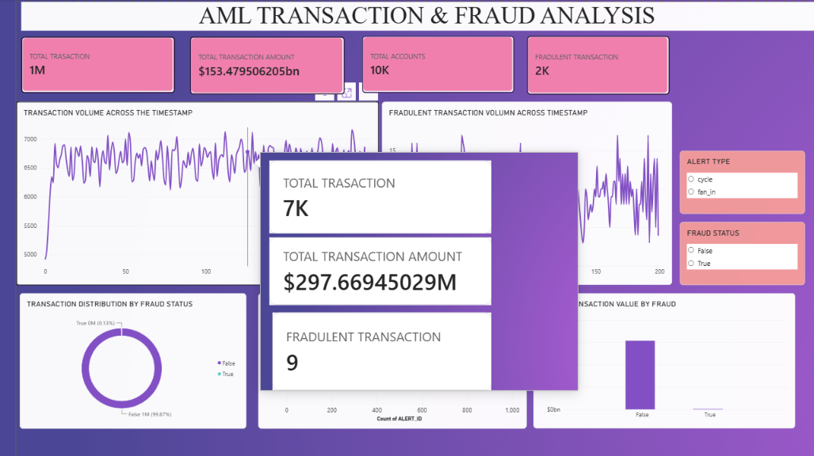

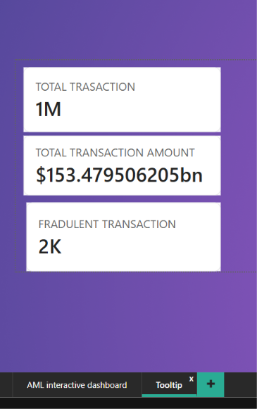

Key findings
  - Transaction Scale vs. Risk: Out of 1 Million total transactions evaluated across 10,000 accounts totaling $153.48bn, exactly 2,000 transactions (0.13%) were confirmed as fraudulent.
  - Laundering Typology Dominance: Circular money laundering paflerns (cycle) represent the primary alert trigger (~920 alerts), followed closely by fund-aggregation structuring (fan_in with ~780 alerts).
  - Targeted High-Value Risk: Although fraudulent transactions represent only 0.13% of total volume, they represent a significant regulatory and financial liability that requires automated rule enforcement.
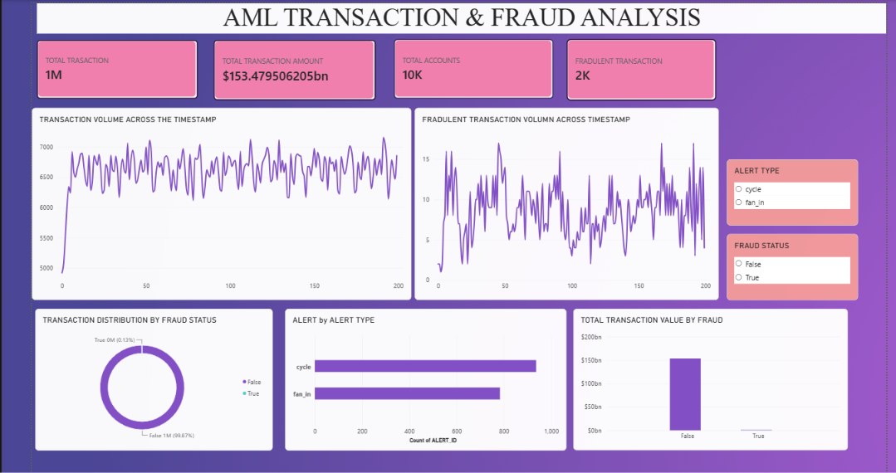

Conclusion
The AML Transaction & Fraud Analysis Dashboard provides an essential operational control center for financial intelligence units. By combining volume tracking with typology-specific alert breakdowns (cycle vs. fan_in), compliance teams can prioritize
high-risk accounts, investigate structured laundering schemes more efficiently, and minimize
financial exposure.

